**Practical-4**

**AIM: Understand and identify Layer-2 functionality.**

**---------------------------------------------------------------------------------------------------------------------------**

Tools required:

1. Desktop Computer
2. Cisco Packet Tracer

Simulate different scenarios given below in Cisco packet tracker and fill up table.

**Note:** While applying IP address, student need to allocate IP address as per his/her student ID. For Example, if student ID is 20ce005 then IP address allocation for first network should start with 5.0.0.0. For subsequent network, it should start with ID+1 i.e. 6.0.0.0, 7.0.0.0. and so on.

**Submission**: After writing answer into this word document, Student need to change name to his ID followed by practical number. Ex 20ce005_Pr1.docx. Upload on assignment segment.

**Rubrics**: Nicely drafted document with clarity in answers leads to full marks. Otherwise, submission carries proportional mark.

**Recommended** to type, avoid copy-past to increase your typing skill.

**Scenario 1:** Let’s assume that there are three PCs in network. All are connected with layer 2 device switch. All are assigned with the shown IP Addresses in the figure 4.1. All ARP tables are empty. Now, PC0 wants to send some data to PC2. How communication will do?

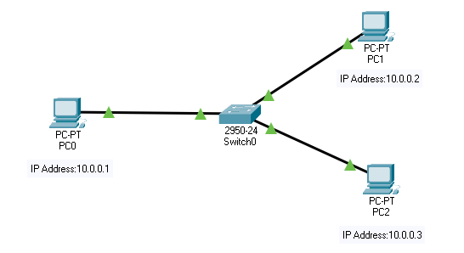

Figure 4.1 Scenario 1

Conclusion: The sender is a host and wants to send a packet to another host on the same network.

* Uses ARP to find another host’s physical address

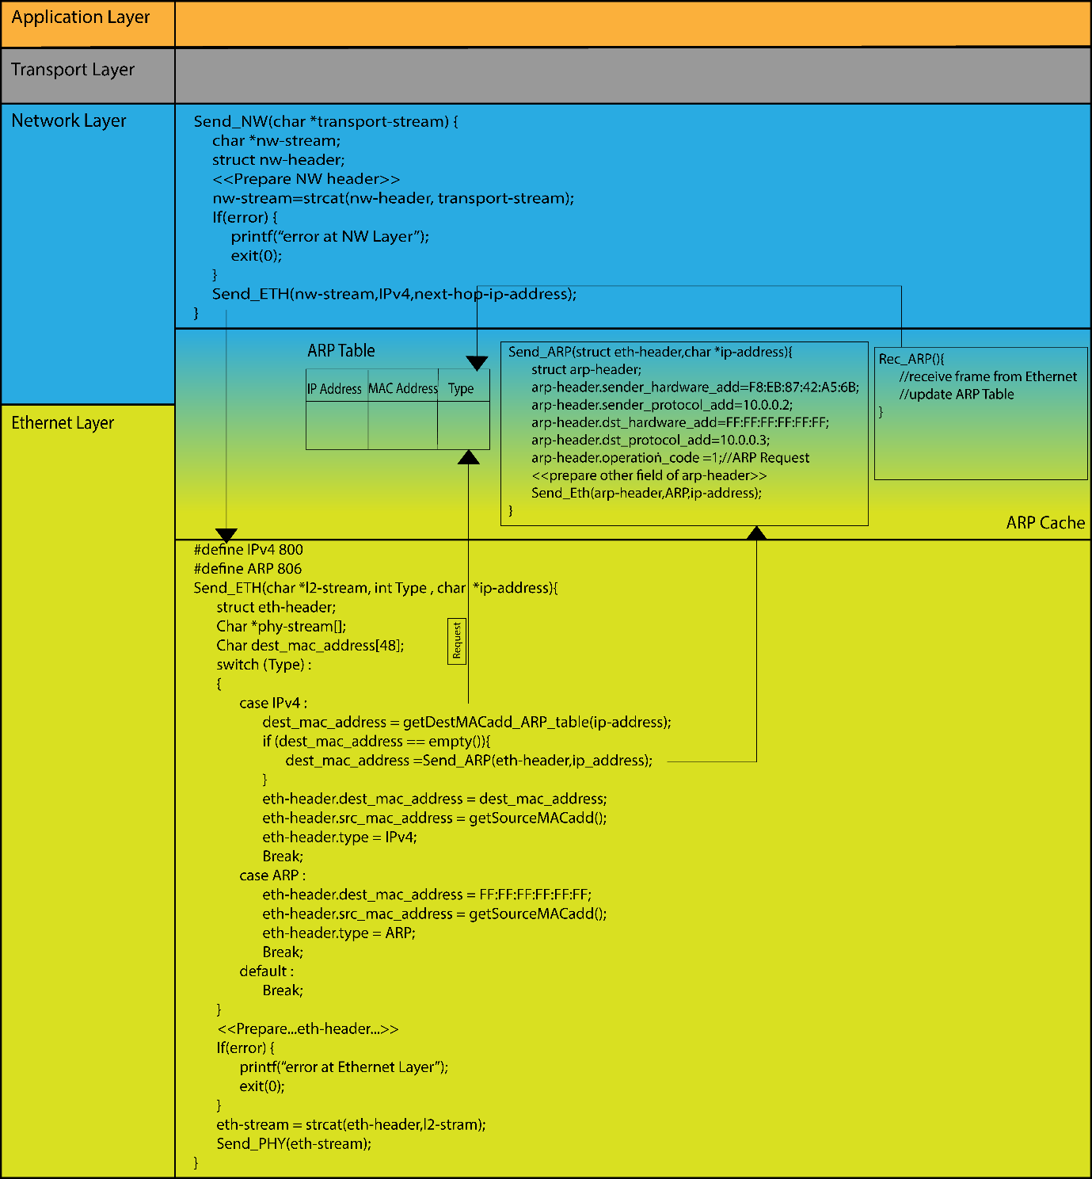

Figure 4.2 TCP/IP stack

**Address Resolution Protocol (ARP):**

Most of the computer programs/applications use logical address (IP address) to send/receive messages, however, the actual communication happens over the physical address (MAC address) i.e., from layer 2 of the TCP/IP model. So, our mission is to get the destination MAC address which helps in communicating with other devices. This is where ARP comes into the picture, its functionality is to translate IP address to physical addresses.

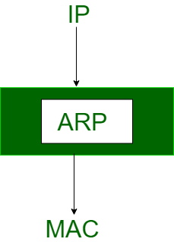

ARP Request

ARP Reply

ARP Table

Figure 4.3 ARP Maps IP address to MAC address

The acronym ARP stands for Address Resolution Protocol which is one of the most important protocols of the Network layer in the OSI model.

ARP finds the hardware address, also known as Media Access Control (MAC) address, of a host from its known IP address.

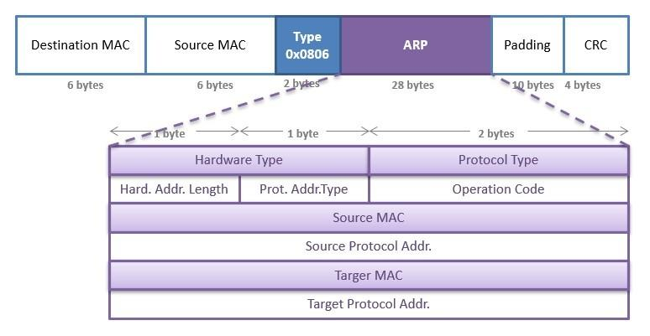

Figure 4.4 ARP header

**Scenario 2:** With respect to given topology shown in figure 4.5, IP addresses are assigned to all the PCs. Initial ARP tables are empty. Now, PC0 wants to send data to PC3. Write down the step how communication will take place.

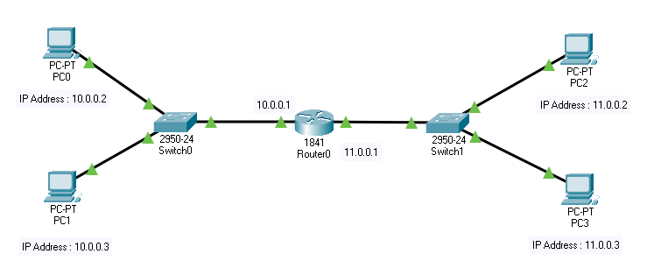

Figure 4.5 Scenario 2

Conclusion: The sender is a host and wants to send a packet to another host on another network.

* The sender looks at its routing table.
* Find the IP address of the next-hop (router) for this destination.
* Use ARP to find the router’s physical address

**Scenario 3:** With respect to given topology shown in figure 4.6, IP addresses are assigned to all the PCs. Initial ARP tables are empty. Now, Packet is received by router 1 with destination IP address 12.0.0.2. Write down the step how communication will take place.

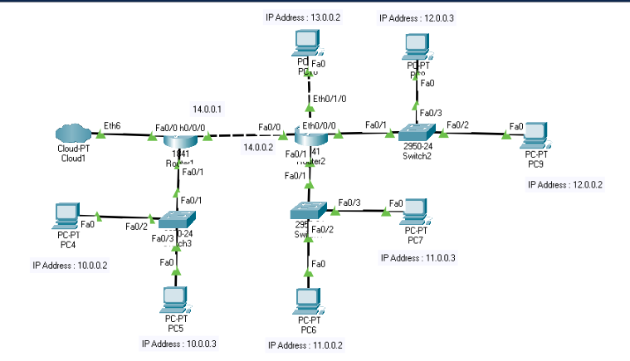

Figure 4.6 Scenario 3

Conclusion: the sender is a router and received a datagram destined for a host on another network.

* The router checks its routing table.
* Find the IP address of the next router.
* Use ARP to find the next router’s physical address.

Question 1: List out Different network devices and give a small introduction of the same.

Ans.

Question 2: write down difference between HUB and SWITCH.

Ans.

**Exercise-1**

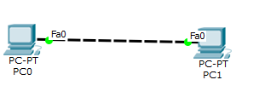

Redraw above diagram which includes IP address and MAC address. Take IP address and MAC address as per your knowledge.

PC0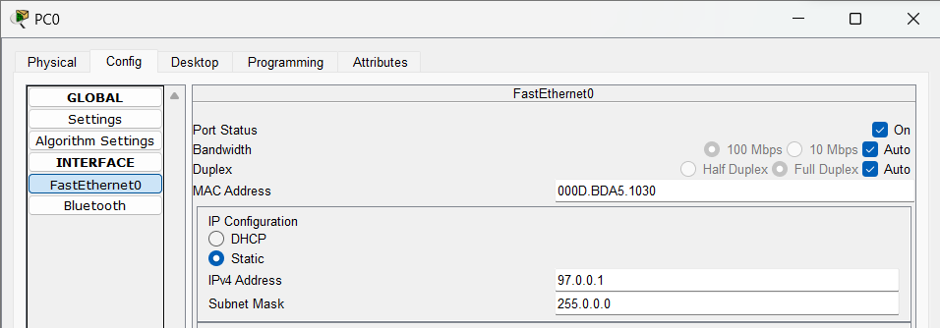

PC1

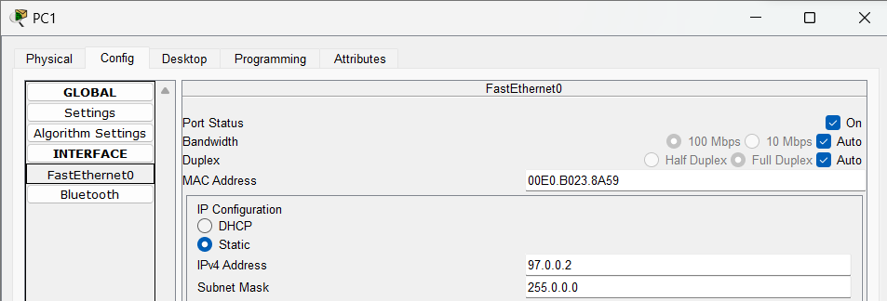

Ping from PC0 to PC1 and vice versa and insert snap of output here.

PC0 to PC1

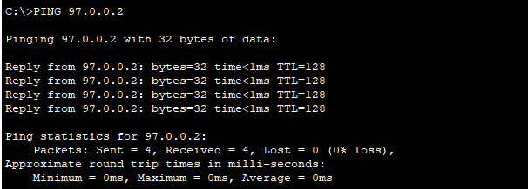

PC1 to PC0

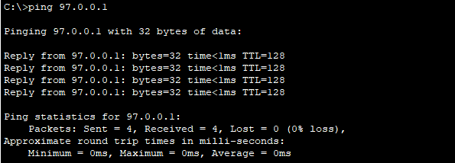

write down ARP table of PC0 and PC1.

Fill ARP table entry of PC0

|  |  |
| --- | --- |
| **IP address** | **MAC Address** |
| 97.0.0.2 | 00E0.B023.8A59 |

Fill ARP table entry of PC1

|  |  |
| --- | --- |
| **IP address** | **MAC Address** |
| 97.0.0.1 | 000d.bda5.1030 |

**Questions:**

1. What does ARP table contain?
2. Why there is need of ARP table?
3. What is topology name of exercise-1?
4. What is relation of IP address with MAC address?
5. Can we change MAC Address of machine?
6. Can we change IP address of machine?

**Exercise-2 :**

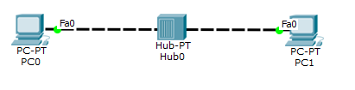

Redraw above diagram which includes IP address and MAC address. Take IP address and MAC address as per your knowledge.

PC0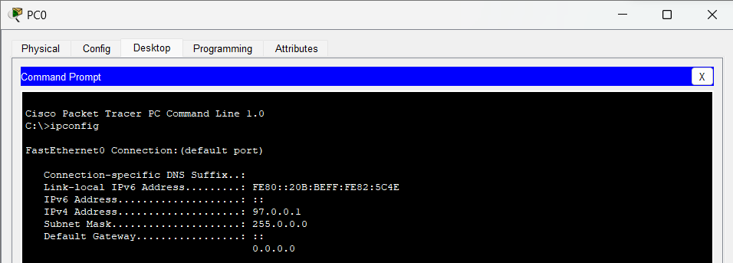

PC1

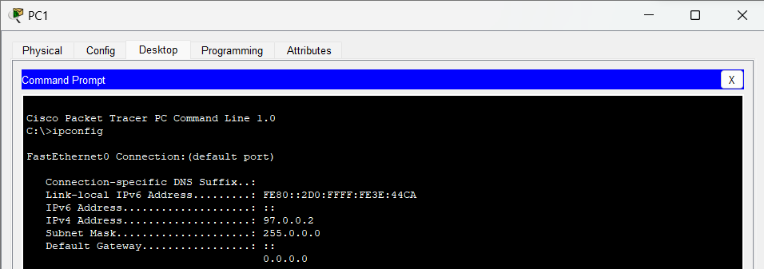

Ping from PC0 to PC1 and vice versa and insert snap of output here.

PC0 to PC1

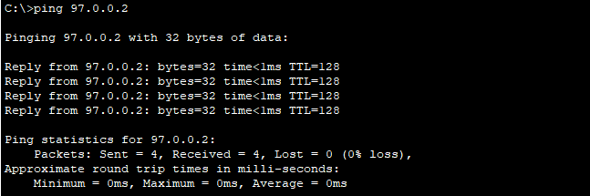

PC1 to PC0

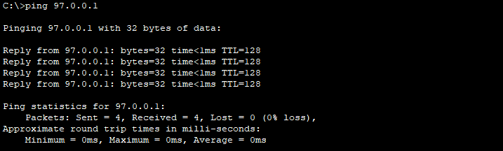

Write down ARP table of PC0 and PC1. Write down switch table of Hub0.

Fill ARP table entry of PC0

|  |  |
| --- | --- |
| **IP address** | **MAC Address** |
| 97.0.0.2 | 00d0.ff3e.44ca |

Fill ARP table entry of PC1

|  |  |
| --- | --- |
| **IP address** | **MAC Address** |
| 97.0.0.1 | 000b.be82.5c4e |

Questions:

1. What is functionality of Hub?
2. Does hub have IP address?
3. Does hub have switch (ARP) table?
4. What is topology of exercise-2?

**Exercise-3**

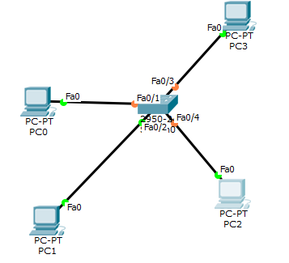

Redraw above diagram which includes IP address and MAC address. Take IP address and MAC address as per your knowledge.

<<Image from student>>

Ping from PC0,PC1,PC2 and PC3 respectively and insert snap of output here.

<<Images from student>>

Write down ARP tables of PC0,PC1,PC2 and PC3. Write down switch table of Switch0.

Fill ARP table entry of PC0

|  |  |
| --- | --- |
| **IP address** | **MAC Address** |
| 97.0.0.2 | 0001.6477.78bb |
| 97.0.0.3 | 0050.0f63.a272 |
| 97.0.0.4 | 0002.17b8.6d85 |

Fill ARP table entry of PC1

|  |  |
| --- | --- |
| **IP address** | **MAC Address** |
| 97.0.0.1 | 0050.0f63.a272 |
| 97.0.0.3 | 0050.0f63.a272 |
| 97.0.0.4 | 0002.17b8.6d85 |

Fill ARP table entry of PC2

|  |  |
| --- | --- |
| **IP address** | **MAC Address** |
| 97.0.0.1 | 0050.0f63.a272 |
| 97.0.0.2 | 0001.6477.78bb |
| 97.0.0.4 | 0002.17b8.6d85 |

Fill ARP table entry of PC3

|  |  |
| --- | --- |
| **IP address** | **MAC Address** |
|  |  |
|  |  |
|  |  |

Fill Switch table entry of Switch0

|  |  |
| --- | --- |
| **MAC Address** | **Ethernet port no** |
|  |  |
|  |  |
|  |  |

Questions:

1. What is functionality of switch?
2. Does switch have IP address?
3. Does switch have switch (ARP) table?
4. What is topology name of exercise-3?

**Exercise-4**

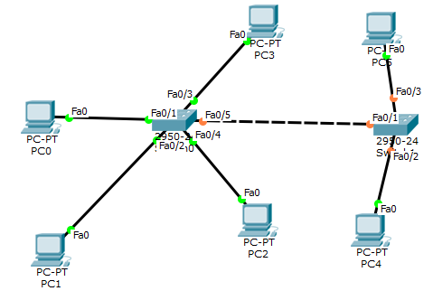

Redraw above diagram which includes IP address and MAC address. Take IP address and MAC address as per your knowledge.

<<Image from student>>

Ping from all given PCs respectively and insert snap of output here.

<<Images from student>>

Write down ARP table of all given PCs. Write down switch table of Switch0 and Switch1.

ARP table entry of PC0

|  |  |
| --- | --- |
| **IP address** | **MAC Address** |
|  |  |
|  |  |
|  |  |

ARP table entry of PC1

|  |  |
| --- | --- |
| **IP address** | **MAC Address** |
|  |  |
|  |  |
|  |  |

ARP table entry of PC2

|  |  |
| --- | --- |
| **IP address** | **MAC Address** |
|  |  |
|  |  |
|  |  |

ARP table entry of PC3

|  |  |
| --- | --- |
| **IP address** | **MAC Address** |
|  |  |
|  |  |
|  |  |

ARP table entry of PC4

|  |  |
| --- | --- |
| **IP address** | **MAC Address** |
|  |  |
|  |  |
|  |  |

ARP table entry of PC5

|  |  |
| --- | --- |
| **IP address** | **MAC Address** |
|  |  |
|  |  |
|  |  |

Switch table entry of Switch0

|  |  |
| --- | --- |
| **MAC Address** | **Ethernet port no** |
|  |  |
|  |  |
|  |  |

Switch table entry of Switch1

|  |  |
| --- | --- |
| **MAC Address** | **Ethernet port no** |
|  |  |
|  |  |
|  |  |

Questions

1. Does both the switch will have identical switching table?
2. In Exercise-4, why does PC0 contain IP MAC address of PC4?
3. What is topology name of exercise-4?